**Performance Comparison of Different Quadrature Methods for Double Integrals of Functions with Wider Variation over a Given Planar Region**

**Ryan Adoni**

**MA346 Numerical Methods Professor Guerra**

**May 17th, 2021**

**I pledge my honor that I have abided by the Stevens Honor System.**

**Abstract:**

There are many different quadrature methods that can be used to approximate a double integral. This report aims to analyze the performance comparison between different quadrature methods for double integrals. Specifically, this reports goal is to examine functions with wider variations over a given planar region and compare quadrature methods in accuracy to evaluate each’s performance.

To conduct the comparisons, a few different quadrature methods were implemented in MATLAB. Composite Trapezoidal, Composite Simpson, and Gaussian Quadrature Rules for double integrals were coded and then adaptation was used to improve their implementations. These methods were ran using the same functions and their results were analyzed.

**Introduction:**

This report sets out to complete three goals. Goal one is to explain and demonstrate six quadrature methods with a focus on the three last methods—the adaptive methods. The first three methods to be demonstrated are the Composite Trapezoidal, Composite Simpson, and Gaussian Quadrature Rules for double integrals and the subsequent three are adaptive variants of the previous methods. Goal two is to code these six methods in MATLAB. Goal three is to compare the different methods, display their outputs and results, and analyze the difference between their results.

**Purpose:**

No one will doubt the usefulness of the numerical quadrature methods for double integrals. They can be used to approximate double integrals when no antiderivative exists and can give a relatively accurate approximation when an antiderivative exists but is hard to compute. Why are adaptive methods needed then? Adaptive quadrature methods for double integrals are useful in that they can be more efficient than classical quadrature methods in that they do not need to sample uniformly from a function and only use points in the quadrature, that would increase the accuracy of the approximation. This allows for a speedup on functions where there may be a wider variation on one part of the function and where other parts of the function are quite uniform. The adaptive versions provide higher accuracy using the same number of points because the number of points, instead of being uniformly sampled from the function are adaptively chosen based on the functions variation. Towards the end of this report, this will be clearly shown.

**Preliminary Examples:**

First, three short examples will be done demonstrating the Composite Trapezoidal Rule, Composite Simpson’s Rule, and the Gaussian Quadrature, so later, these methods can be applied as steps without showing all work.

One common use of numerical integration is integrating a function with no antiderivative such as a 2-dimensional Gaussian function. The function below is one example of a 2-D Gaussian with $σ^{2}=0.2$, graphed using GeoGebra (The image below does not show the entire region).



$$g\left(x, y\right)=\frac{1}{2π(0.2)}e^{\frac{-(x^{2}+y^{2})}{2(0.2)}}, x∈\left[-5, 5\right], y∈\left[-5, 5\right]$$

**Composite Trapezoidal Rule**

The rule is defined below.

Let $h=\frac{b-a}{n}, k=\frac{d-c}{m}, x_{i}=a+ih$, $y_{i}=c+jk$, $i=0, 1, 2,. . . , n, j=0, 1, 2, . . ., m$

$$\int_{a}^{b}{\int_{c}^{d}{f(x, y)dydx}≈ }$$

$\frac{hk}{4}\left( f\left(a, c\right)+f\left(a, d\right)+f\left(b, c\right)+f\left(b, d\right)\right)+$

$\frac{hk}{2}[\sum_{i=1}^{n-1}{f\left(x_{i}, c\right)+\sum_{i=1}^{n-1}{f\left(x_{i}, d\right)}}+\sum_{j=1}^{m-1}{f\left(a, y_{j}\right)}+\sum_{j=1}^{m-1}{f\left(b, y_{j}\right)]+}$

$\sum_{i=1}^{n-1}{\sum_{j=1}^{m-1}{f\left(x_{i}, y_{j}\right)}}$

Define $T(a,b,c,d,n,m)$ be the approximation given by the Composite Trapezoidal Rule with $n$ subintervals in the $x$ direction and $m$ intervals in the $y$ direction with $x∈\left[a, b\right], y∈\left[c, d\right]$. This will be used In the adaptive variant without explanation now.

**Example**

using $n=m=10$ and integrating $g(x,y)$ from above on $x∈\left[-5, 5\right], y∈\left[-5, 5\right]$, we get the following:

$h=\frac{5-(-5)}{10}=1, k=\frac{5-(-5)}{10}=1, x_{i}=i-5$, $y_{i}=j-5$

$$\int_{-5}^{5}{\int_{-5}^{5}{\frac{1}{2π(0.2)}e^{\frac{-(x^{2}+y^{2})}{2(0.2)}}dydx}≈ }$$

$$\frac{(1)(1)}{4}\left( g\left(-5, -5\right)+g\left(-5, 5\right)+g\left(5, -5\right)+g\left(5, 5\right)\right)+$$

$\frac{(1)(1)}{2}[\sum_{i=1}^{10-1}{g\left(x_{i}, -5\right)+\sum_{i=1}^{10-1}{g\left(x_{i}, 5\right)}}+\sum_{j=1}^{10-1}{g\left(-5, y_{j}\right)}+\sum_{j=1}^{10-1}{g\left(5, y_{j}\right)]+}$

$\sum_{i=1}^{10-1}{\sum_{j=1}^{10-1}{g\left(x_{i}, y_{j}\right)}}≈1.63473357199483$

**Composite Simpson’s Rule**

The rule is defined below.

Let $h=\frac{b-a}{n}, k=\frac{d-c}{m}, x_{i}=a+ih$, $y_{i}=c+jk$, $i=0, 1, 2,. . . , n, j=0, 1, 2, . . ., m$

$$\int_{a}^{b}{\int_{c}^{d}{f(x, y)dydx}≈ }$$

$\frac{hk}{9}\{[ f\left(x_{0},y_{0}\right)+ 2\sum_{i=1}^{\frac{n}{2}-1}{f\left(x_{2i}, y_{0}\right)+ 4\sum_{i=1}^{\frac{n}{2}}{f\left(x_{2i-1}, y_{0}\right)+f\left(x_{n},y_{0}\right)]+}}$

$2[\sum_{j=1}^{\frac{m}{2}-1}{f\left(x_{0}, y_{2j}\right)+}2\sum_{j=1}^{\frac{m}{2}-1}{\sum_{i=1}^{\frac{n}{2}-1}{f\left(x_{2i}, y_{2j}\right)+}}$

$4\sum_{j=1}^{\frac{m}{2}-1}{\sum_{i=1}^{\frac{n}{2}}{f\left(x_{2i-1}, y_{2j}\right)+}}\sum_{j=1}^{\frac{m}{2}-1}{f\left(x_{n}, y_{2j}\right)]+}$

$4[\sum_{j=1}^{\frac{m}{2}}{f\left(x_{0}, y_{2j-1}\right)+}2\sum_{j=1}^{\frac{m}{2}}{\sum_{i=1}^{\frac{n}{2}-1}{f\left(x_{2i}, y_{2j-1}\right)+4\sum_{j=1}^{\frac{m}{2}}{\sum_{i=1}^{\frac{n}{2}}{f\left(x_{2i-1}, y_{2j-1}\right)+}}}}$ $\sum_{j=1}^{\frac{m}{2}}{f\left(x_{n}, y_{2j-1}\right)}]+$

$[ f\left(x_{0},y_{m}\right)+ 2\sum_{i=1}^{\frac{n}{2}-1}{f\left(x_{2i}, y_{m}\right)+ 4\sum_{i=1}^{\frac{n}{2}}{f\left(x_{2i-1}, y_{m}\right)+f\left(x_{n},y_{m}\right)]\}}}$

Define $S(a,b,c,d,n,m)$ be the approximation given by the Composite Simpson’s Rule with $n$ subintervals in the $x$ direction and $m$ intervals in the $y$ direction with $x∈\left[a, b\right], y∈\left[c, d\right]$. This will be used In the adaptive variant without explanation now.

**Example**

using $n=m=10$ and integrating $g(x,y)$ from above on $x∈\left[-5, 5\right], y∈\left[-5, 5\right]$, we get the following:

$h=\frac{5-(-5)}{10}=1, k=\frac{5-(-5)}{10}=1, x_{i}=i-5$, $y_{i}=j-5$

$$\int_{-5}^{5}{\int_{-5}^{5}{\frac{1}{2π(0.2)}e^{\frac{-(x^{2}+y^{2})}{2(0.2)}}dydx}≈ }$$

$\frac{(1)(1)}{9}\{[ f\left(-5,-5\right)+ 2\sum_{i=1}^{\frac{10}{2}-1}{f\left(x_{2i}, -5\right)+ 4\sum_{i=1}^{\frac{10}{2}}{f\left(x_{2i-1}, -5\right)+f\left(5,-5\right)]+}}$

$2[\sum_{j=1}^{\frac{10}{2}-1}{f\left(-5, y_{2j}\right)+}2\sum_{j=1}^{\frac{10}{2}-1}{\sum_{i=1}^{\frac{10}{2}-1}{f\left(x_{2i}, y_{2j}\right)+}}$

$4\sum_{j=1}^{\frac{10}{2}-1}{\sum_{i=1}^{\frac{10}{2}}{f\left(x_{2i-1}, y_{2j}\right)+}}\sum_{j=1}^{\frac{10}{2}-1}{f\left(5, y_{2j}\right)]+}$

$4[\sum_{j=1}^{\frac{10}{2}}{f\left(-5, y_{2j-1}\right)+}2\sum_{j=1}^{\frac{10}{2}}{\sum_{i=1}^{\frac{10}{2}-1}{f\left(x_{2i}, y_{2j-1}\right)+4\sum_{j=1}^{\frac{10}{2}}{\sum_{i=1}^{\frac{10}{2}}{f\left(x_{2i-1}, y_{2j-1}\right)+}}}}$ $\sum_{j=1}^{\frac{10}{2}}{f\left(5, y_{2j-1}\right)}]+$

$[ f\left(-5, 5\right)+ 2\sum_{i=1}^{\frac{10}{2}-1}{f\left(x_{2i}, 5\right)+ 4\sum_{i=1}^{\frac{10}{2}}{f\left(x_{2i-1}, 5\right)+f\left(5, 5\right)]\}}}≈2.86767866984066$

**Gaussian Quadrature**

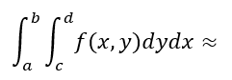The rule is defined below.

$\frac{(b-a)}{2}∙\frac{(d-c)}{2}\sum_{i=1}^{n}{c_{n, i}\sum_{j=1}^{m}{c_{m, j}f(\frac{\left(b-a\right)r_{n,i} + b + a}{2}, \frac{\left(d-c\right)r_{m,j} + d + c}{2})}}$

Define $G(a,b,c,d,n,m)$ be the approximation given by the Composite Simpson’s Rule with $n$ subintervals in the $x$ direction and $m$ intervals in the $y$ direction with $x∈\left[a, b\right], y∈\left[c, d\right]$. This will be used In the adaptive variant without explanation now.

**Example**

$$\int_{-5}^{5}{\int_{-5}^{5}{\frac{1}{2π(0.2)}e^{\frac{-(x^{2}+y^{2})}{2(0.2)}}dydx}≈ }$$

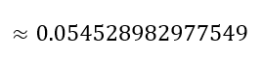 $\frac{(-5-(-5))}{2}∙\frac{(-5-(-5))}{2}\sum_{i=1}^{n}{c_{n, i}\sum_{j=1}^{m}{c_{m, j}f(\frac{\left(-5-(-5)\right)r_{n,i} - 5 - 5}{2}, \frac{\left(-5-(-5)\right)r_{m,j} - 5 - 5}{2})}}≈$

With these examples, it can clearly be seen that not enough intervals are being used as the integral should be approximately equal to 1 as the 2D Gaussian is a probability density function. With higher values for $n$ and $m$ these integrals can be approximated better, however, as it can be seen in the next section, these approximations can take longer amounts of time to run if m and n are substantially high. More accurate approximations for the above example can be obtained with $n=m>10$. Adaptive methods can remedy this, giving better estimates with the same (or less) points.

**Adaptive Methods:**

The next three methods will are all adaptive variants of the three previous ones. All three methods follow the same general steps:

1. Initialize a list of regions needed to be approximated, $L$ (initially the region $x∈\left[a, b\right], y∈\left[c, d\right]$ for this report).
2. Initialize a variable for holding the current approximation, $J$.
3. Repeat the following steps until the List, $L$, is empty:
   1. Remove the first region from the list $L$ and do the following steps using that region.
   2. Calculate a coarse approximation using one of the aforementioned rules, $C.$
   3. Calculate a fine approximation using one of the aforementioned rules, $F.$
   4. If the absolute value of the difference of the coarse and fine approximation differ by a value less than epsilon, then add the fine approximation to $J$, otherwise divide the region and place all subregions in the list $L.$ More technically, If $\left|C-F\right|<ε$ add $F$ to $J$ else divide the region and place the subregions in $L$.
   5. Go to 3.
4. Return $J$ as the approximation.

**Adaptive Composite Trapezoidal Method**

Using the above outline, the first few steps using the Adaptive Composite Trapezoidal Method are calculated using the example from above and $ε=0.1$:

$$g\left(x, y\right)=\frac{1}{2π(0.2)}e^{\frac{-(x^{2}+y^{2})}{2(0.2)}}, x∈\left[-5, 5\right], y∈\left[-5, 5\right]$$

$L=\{(-5, 5,-5, 5)\}$ (each 4-tuple is in the form $(a, b, c, d)$), $J=0$

**Iteration 1**

Use $\left(-5, 5,-5, 5\right)$ as the current region and remove the region from $L$ such that $L=\{\}$

$C= T\left(-5, 5,-5, 5, 1, 1\right)≈ {4.248}^{-107}$, $F= T\left(-5, 5,-5, 5, 2, 2\right)≈39.788$

Because $\left|{4.248}^{-107}-39.788\right|>0.1$ we divide the region into four subregions and add them to $L$. $L= \{\left(-5, 0,-5, 0\right), \left(-5, 0, 0, 5\right), \left(0, 5,-5, 0\right), \left(0, 5, 0, 5\right)\}$ now

**Iteration 2**

Use $\left(-5, 0,-5, 0\right)$ as the current region and remove the region from $L$ such that $L= \{\left(-5, 0, 0, 5\right), \left(0, 5,-5, 0\right), \left(0, 5, 0, 5\right)\}$

$C= T\left(-5, 0,-5, 0, 1, 1\right)≈ 9.947$, $F= T\left(-5, 0,-5, 0, 2, 2\right)≈2.486$

Because $\left|9.947-2.486\right|>0.1$ we divide the region into four subregions and add them to $L$. $L=\{\left(-5, 0, 0, 5\right), \left(0, 5,-5, 0\right), \left(0, 5, 0, 5\right), \left(-5, -2.5, -5, -2.5\right), \left(-5, -2.5, -2.5, 0\right),$

$\left(-2.5, 0, -5, -2.5\right), (-2.5, 0, -2.5, 0)\}$ now

**Iteration 3, 4 and 5 are similar to iterations 1 and 2 so they are skipped here. During these iterations only $L$ changes.**

**Iteration 6**

Use $\left(-5, -2.5, -5, -2.5\right)$ as the current region and remove the region from $L$ such that $L= \{\left(-5, -2.5, -2.5, 0\right),\left(-2.5, 0, -5, -2.5\right), (-2.5, 0, -2.5, 0)$

$\left(-5, -2.5, 0, 2.5\right), \left(-5, -2.5, 2.5, 5\right), \left(-2.5, 0, 0, 2,5\right), \left(-2.5, 0, 2.5, 5\right),$

$\left(0, 2.5, -5, -2.5\right), \left(0, 2.5, -2.5, 0\right), \left(2.5, 5, -5, -2.5\right), \left(2.5, 5, -2.5, 0\right),$

$\left(0, 2.5, 0, 2.5\right), \left(0, 2.5, 2.5, 5\right), \left(2.5, 5, 0, 2.5\right), \left(2.5, 5, 2.5 5\right)\}$

$C= T\left(-5, -2.5, -5, -2.5, 1, 1\right)≈ {1.787}^{-27}$, $F= T\left(-5, -2.5, -5, -2.5, 2, 2\right)≈{4.468}^{-28}$

Because $\left|{1.787}^{-27}-{4.468}^{-28}\right|<0.1$ we add $F$ to $J$, this $J={4.468}^{-28}$ now

**The algorithm now continues until $L$ is empty.**

Following this algorithm through the final value returned will be $J=1.000319299274843$

**Adaptive Composite Simpson’s Method & Adaptive Gaussian Method**

These two methods are identical to the previous one except for one detail so it would be a waste of space to copy and paste the previous structure and alter the numbers. Besides the difference that instead of the using $T(a,b,c,d,n,m)$, $S\left(a,b,c,d,n,m\right)$ or $GQ(a,b,c,d,n,m)$ would be used, respectively, the only difference is in how the fine approximation is calculated. For the Composite Simpson’s and Gaussian Quadrature Methods, the region is divided as such and step (d) from above is altered in the following way:

Using $h=\frac{b-a}{2}, k=\frac{d-c}{2}$

$$F= S\left(a,h,c,k,2, 2\right)+ S\left(a,h,k,d,2, 2\right)+ S\left(h,b,c,k,2, 2\right)+S\left(h,b,k,d,2, 2\right)$$

The Adaptive Gaussian Quadrature is calculated the same way except using $GQ(a,b,c,d,n,m)$. The previous rules apply and C is defined similar to the Adaptive Composite Trapezoidal Method, $C= S\left(a, b, c, d, 1, 1\right)$ or $C=GQ\left(a, b, c, d, 1, 1\right)$.

**Comparisons of Methods using Code**

Moving to a new example we look at $h\left(x,y\right)=ysin\left(x\right)+xcos(y)$, $x∈\left[-π,\frac{3π}{2}\right], y∈\left[0, 2π\right]$



Solving $\int_{-π}^{\frac{3π}{2}}{\int_{0}^{2π}{h(x, y)dydx}}$ analytically:

$\int_{-π}^{\frac{3π}{2}}{\int_{0}^{2π}{ysin\left(x\right)+xcos\left(y\right)dydx= }}-2π^{2}=-19.739208802178717$. . .

**Table 1: Comparisons of Double Integral Approximation Methods**

|  |  |  |  |  |  |
| --- | --- | --- | --- | --- | --- |
|  | Approximation | Absolute Error | Relative Error | Number of Points | Parameters |
| Composite Trapezoidal | -19.562734196637798 | 0.176474605540919 | 0.89% | 1849 | $$n=42$$ $$m=42$$ |
| Adaptive Composite Trapezoidal | -19.721609387323273 | 0.017599414855444 | 0.09% | 1821 | $$ε=0.0095$$ |
| Composite Simpson’s | -18.540220781877526 | 1.198988020301191 | 6.07% | 1848 | $$n=43$$ $$m=43$$ |
| Adaptive Composite Simpson’s | -19.743006049380920 | 0.003797247202203 | 0.02% | 1910 | $ε=1$.2 |
| Gaussian Quadrature | -19.739208802178720 | $$3×{10}^{-15}$$ | < 0.01% | 1849 | $$n=43$$ $$m=43$$ |
| Adaptive Gaussian Quadrature | -19.739122414498645 | $${8.638768072×10}^{-5}$$ | < 0.01% | 1887 | $$ε=0.1$$ |

Attempting to hold the number of points relatively constant by arbitrarily using $ε=0.1$ for the Adaptive Gaussian Quadrature and tuning the other parameter values for the other methods we get the above table. Setting low values of epsilon for The Adaptive Simpson’s Method or The Adaptive Gaussian Quadrature yield very dense sections and can actually show the contours of a function. Here is one such example using $ε=0.1$ with The Adaptive Simpson’s Method:

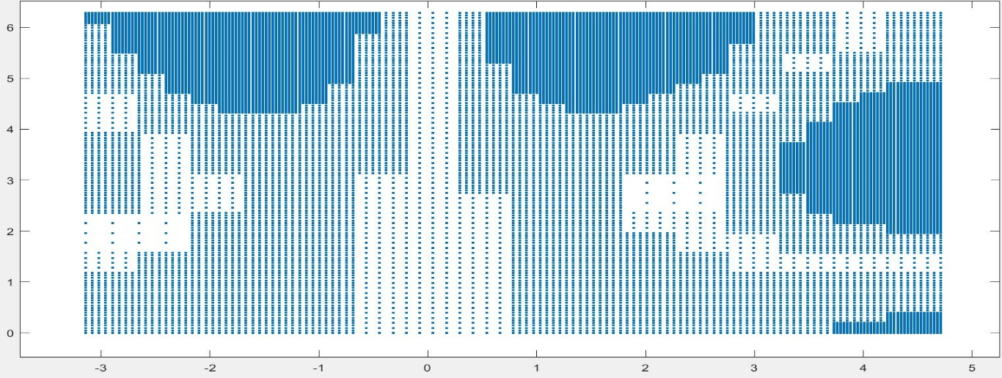

**Visualization of Quadrature Points**

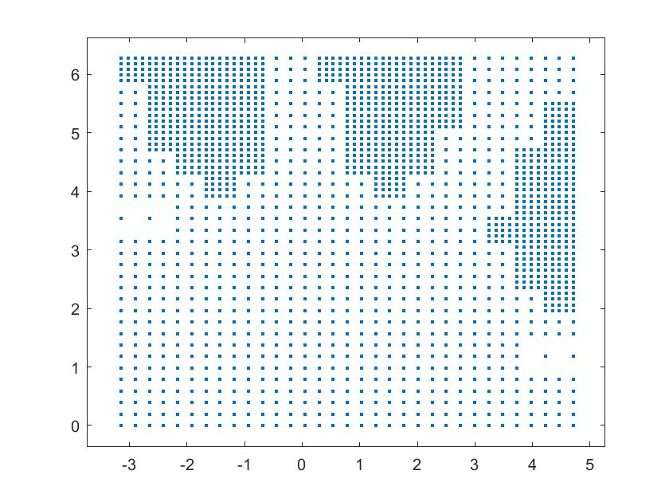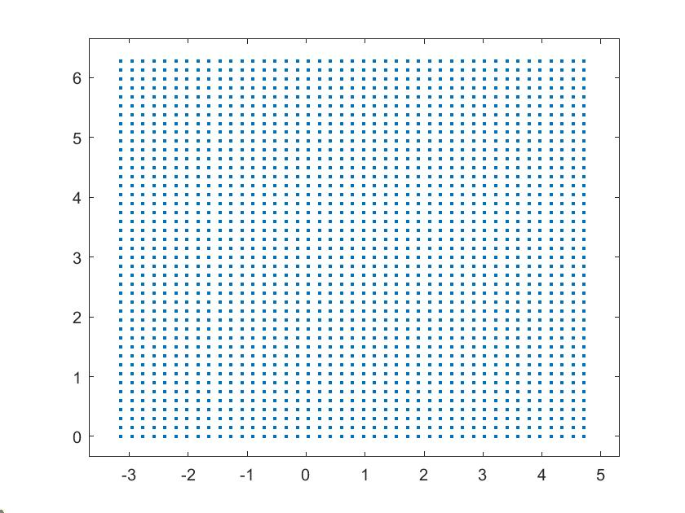 **Composite Trapezoidal Rule Adaptive Composite Trapezoidal Rule**

**Composite Simpson’s Rule Adaptive Composite Simpson’s Rule**

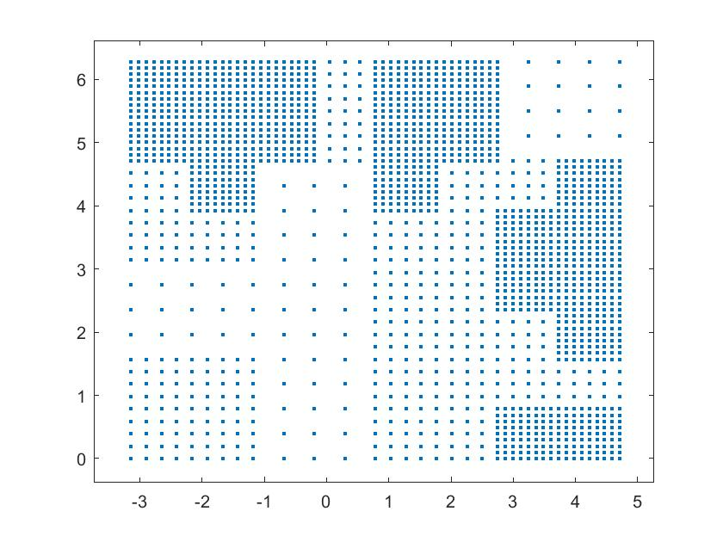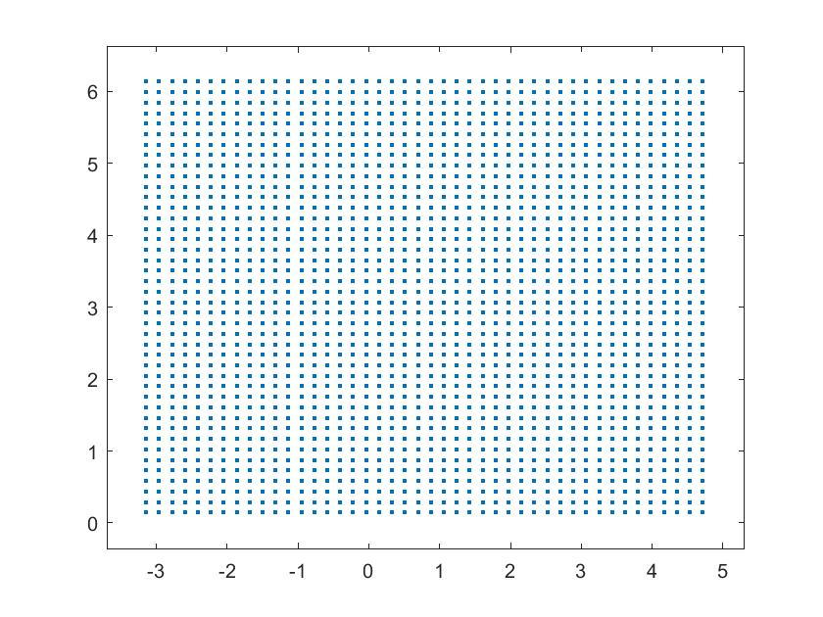

**Gaussian Quadrature Adaptive Gaussian Quadrature**

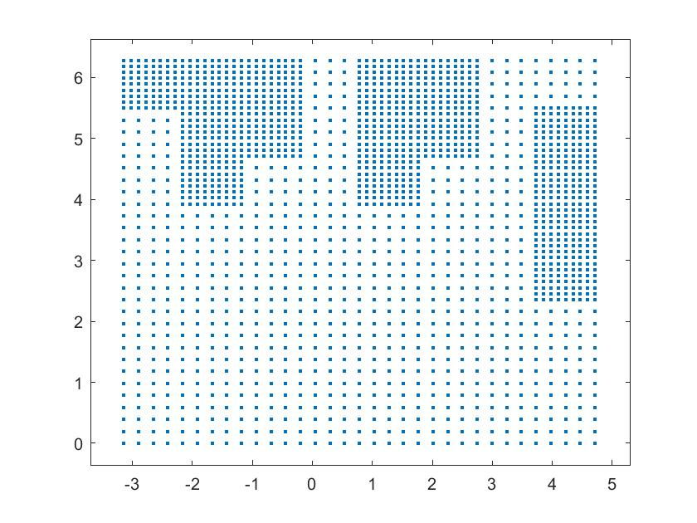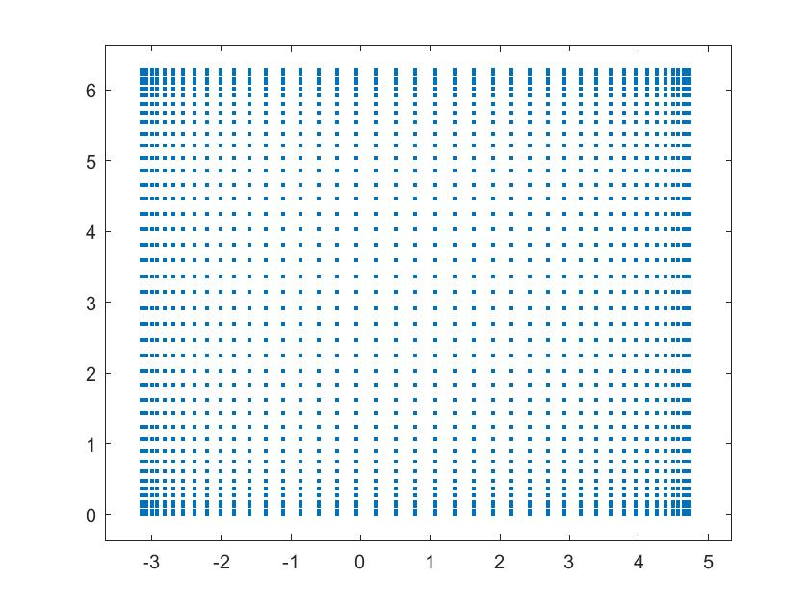

**Report’s Accomplishments:**

This report has accomplished exactly what it set out to accomplish. It has demonstrated three quadrature methods to estimate double integrals—the Composite Trapezoidal Rule, the Composite Simpson’s Rule, and the Gaussian Quadrature. The report showed their adaptive variants and compared their results on functions with variations over a planar region. The code implemented clearly show the adaptive variants and the images above demonstrate the sampling that takes place when using either. The graphs above, clearly demonstrate the differences between the methods and how they sample points differently from the function they integrate over.

**Observations:**

Looking at some of the results above it seems as though the adaptive methods are generally better when using the same / similar number of points. The Composite Trapezoidal and Composite Simpson’s Rule Methods improved greatly when using adaptation. The Gaussian Quadrature, although more accurate than the other methods, seemed to actually decrease in accuracy when using adaption. It seems like a potential reason for this is because the fine approximation and coarse approximation are very close (their absolute difference is smaller than epsilon), but different enough that areas with variation are not explored as much as they could or should be. This can be clearly seen in the above visualizations and specifically looking at the differences between The Adaptive Composite Simpson’s Method and the Adaptive Gaussian Quadrature Method. The adaptive Simpson’s Method very clearly samples more points where there is more variation. Adapting the rule for exploring more points in a local neighborhood can probably be improved to get better results.

Additionally, it is clear that by using the same / similar number of points in a *smarter* way by using more where there is more variation and less where there is less variation can be a clear way to speed up accuracy and speed as now less points can be used to get a better approximation.

**Conclusions:**

Ultimately, this report was successful as it accomplished its goals and compared and contrasted the methods it set out to. The code implemented works well and demonstrates all the methods. There is room for improvement with the Adaptive Gaussian Quadrature, but ultimately the goals of the report were met and it was seen how adaptive methods can be extremely useful in improving accuracy without costing extra computation.

**References**

Burden, Richard L., et al. *Numerical Analysis*. Brooks Cole, 2016.

Gander, W., Gautschi, W. Adaptive Quadrature—Revisited. BIT Numerical Mathematics 40, 84–101 (2000). https://doi.org/10.1023/A:1022318402393, https://www.researchgate.net/publication/226706221_Adaptive_Quadrature-Revisited

**Code Attached in the .zip File**